Guide to Assembling an Electronic Dossier
Revised April 2023
Candidates for tenure and promotion often have questions about what should or should not be included in the dossier they must submit to FPC. Members of FPC appreciate it if candidates submit the right amount and type of materials in a well-organized fashion. This document is an attempt to provide clarity for candidates. The items in the "Evidence" parts of Section 2.6.4 of the Faculty Handbook are listed below in the order in which FPC would like them to appear in the dossier. Comments and suggestions are included, in italics, to give the candidate an idea of what FPC expects.
If a candidate has questions about any of the suggestions below, or needs clarification on any aspect of compiling the dossier, the candidate is encouraged to consult with the chair of FPC. The candidate is also encouraged to talk with peers who have recently been successful in the process in addition to the department chair, and to look at several people's dossiers to see what was done well.
Organization of the Electronic Dossier
- Prior to an FPC review, the candidate will be provided access to a blank e-portfolio in order to create their dossier.
- All documents for review must be uploaded to the e-portfolio dossier and may not be linked to outside cloud services such as OneDrive, Dropbox, &c.
- Horizontal tabs are already present in your blank e-portfolio (see Figure 1); these should not be changed as they correspond to contents of the dossier mentioned in the Faculty Handbook in sections 2.7.3.1.1, 2.6.4.1.1, 2.6.4.2.2, and 2.6.4.3.2.
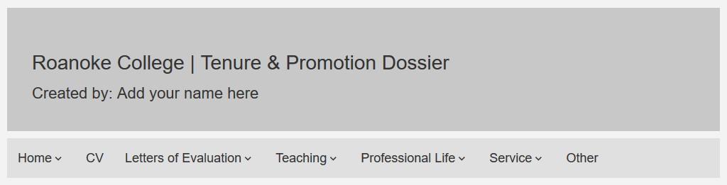

Figure 1. Horizontal Tabs

- Within each tab, vertical sections of the dossier are already present in the e-portfolio (see Figure 2); these should not be changed as they correspond to specific items required for each tab mentioned in the Faculty Handbook sections listed above.

Figure 2. Vertical Tabs, Teaching Section
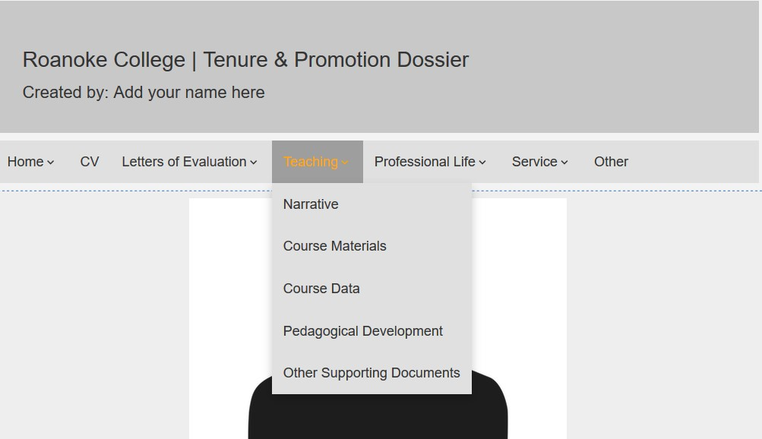

- To edit text within a section, click on the Edit icon (see Figure 3). To upload a file, you can simply drag and drop it from wherever you have your file saved. It’s recommended that you save files in pdf format before uploading.
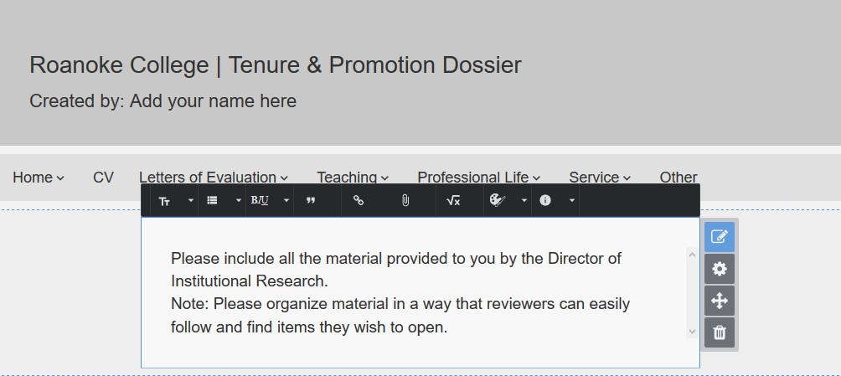

Edit Icon

What follows is the advice and guidelines you should follow while completing the individual tabs and sections of your electronic dossier.

COVER LETTER (for further details, please see the comments on the contents of the Cover Letter appearing in the Faculty Handbook, section 2.7.3.1.1)
- Eligible candidates (faculty who were employed at Roanoke College prior to August 19, 2009) who wish to be evaluated under the Professional Life criteria contained in the 2009 Faculty Handbook (old standards), rather than the current standards, should declare their preference in their cover letter. If no preference is declared, FPC will assume the candidate wishes to be evaluated under the new or current standards.
- Candidates are reminded to explicitly mention the type of review (pre-tenure review, tenure with promotion to Associate Professor, or promotion to Professor) and secondary area of emphasis (professional life or service) under which to be evaluated. Candidates for full professor should include the range of years to be considered for review (please see section 2.6.3.5.1 of the faculty handbook).
- The cover letter should appear under the “Cover Letter” section of the “Home” tab.
CURRENT CURRICULUM VITAE
- Your CV should appear in the “CV” section of the “CV” tab.

LETTERS OF EVALUATION (see explanation in Faculty Handbook, section 2.7.3.1.1, Contents)
- This tab is where all of your letters of evaluation, including any evaluations provided by your department chair during the period of review, should appear.
- The evaluation letters from your department chair (or Associate Dean, if applicable), departmental committee, general education director, and honors program director will be automatically added to your e-portfolio when they are received by the Dean’s Office. If appropriate, the “Pre-Tenure Review” letter will also be added by the Dean’s Office.
- You are responsible for adding your scanned copies of signed conducted during the period under review to the “Evaluations” section of the “Letters of Evaluation” tab. If you do not have these in electronic format, please contact your department chair or supervisor, or, as a last resort, the Dean’s Office.

TEACHING (see Faculty Handbook, section 2.6.4.1.1, Evidence)
1. Teaching Narrative
- A statement of the candidate's teaching goals and philosophy (e.g., reasons for teaching as one does, expectations of self and students);
- A review of what the candidate has learned about teaching during recent years, what changes the candidate has made in his/her teaching, and what problems the candidate has encountered (solved and unsolved), and what actions the candidate has taken to attempt to resolve them;
- A statement of the candidate's primary teaching goals for the next several years and a plan for achieving those goals;
- A statement of how the candidate's teaching is tied to and shaped by his/her activities in Professional Life and Service.
- It is helpful to FPC to have each of these items specifically labeled with the letters (a), (b), (c), and (d), rather than have these blend together; they should be included as a single file appearing in the “Narrative” section of the “Teaching” tab of your dossier.
- In many ways the narrative is the most important part of the dossier, especially in the area of teaching. When describing your teaching methods, make sure to include your philosophy on the use of technology and other resources. Ideally the narrative should be a reflective statement that gives FPC a good sense of what you are trying to accomplish in the classroom and with students (your goals), how you go about accomplishing that, how your methods (and perhaps goals) have evolved, and where you see yourself going as a teacher. The statement should not be merely an abstract statement of teaching philosophy; it should relate your philosophy to what you actually do. In particular the statement should include a discussion of how the materials submitted in the dossier (for example, syllabi, tests, assignments, projects, curricular innovations, individual work with students) exemplify your philosophy and goals. One role of the narrative is to put aspects of the dossier into perspective for the committee. Highlight in the narrative what you wish the committee members to see in the dossier materials.
- In addition to discussing your course materials, the committee will especially be interested in an explanation of how you have interpreted student evaluations, grade distribution data, and, if appropriate, what actions you have taken in response to these. All of these things might inform aspects of your classroom, such as: appropriately rigorous expectations of student learning, creation of a positive learning environment, providing clear and fair assessments, and other areas detailed in handbook sections 2.6.1.1.3 and 2.6.2.1.3.3. You may want to comment on the assessment of your work by others (your department chair, for example), indicating the role these assessments have played in your development as a teacher or giving your analysis of the assessments is appropriate.
- A final piece of advice: the narrative should be as succinct as seems reasonable. Teaching narratives vary in length due to individual circumstances but FPC believes that narratives that are 3000 to 4000 words in length are generally sufficient. Overly long, repetitive narratives are not particularly appreciated by the committee. For example, while it is helpful to address the full range of courses taught, rather than elaborating on each one (if the number of courses is considerable), examples can be given from syllabi, exams, and assignments in order to illustrate a point in the narrative. For instance, categories may include introductory level versus upper level electives within your discipline, general education courses in relation to courses within a major, courses that include service learning.
2. Course Materials
  - List all courses from the six most recent regular semesters in which the candidate taught, plus the most recent Intensive Learning course taught, if any. In addition, special topics courses, Intensive Learning courses, or other courses taught outside this time frame, which demonstrate the range and quality of the candidate's teaching, may also be included;
  - For each different course listed in 2.a. above, please include the following organized by course: i. Course syllabus/policy statement; ii. Final exam and selected tests/quizzes;
iii. Selected assignments;
  - Annotated list of independent studies including theses directed, honors in the major projects, summer scholars advised, and internships supervised, or other instances in which you have facilitated student research or provided mentoring outside of regular class instruction or advising. Briefly (in one sentence or two) describe the nature of the project and your involvement;
- The list of courses requested by 2.a above should be included in the “Course Lists” section of the “Teaching” tab and may either be entered directly on that page as a bulleted list or included in an uploaded file. The annotated list of independent students, and such, requested by 2.c should be included in this same section (either as another bulleted list or as a separate uploaded file).
- The items requested by 2.b above should appear in the “Course Materials” section of the “Teaching” tab. Please include bulleted headings for each course, and beneath each course, use sub-bullets for each of i, ii, and iii listed in 2.b above. Beneath the sub-bullets, upload your items using appropriate labels so that FPC knows what they are.
- If multiple sections of a course have been taught, either in the same semester or different semesters, do not include copies of every final exam if the exams are very similar. One copy of a representative final exam will suffice. If the course has evolved over time, include enough sample exams to show the changes, and comment on the evolution of the course in the narrative.
- Do not include all tests and quizzes you have given. Include examples that are representative of the type of testing you do and that illustrate what you said about your testing philosophy in the narrative. Similarly include samples of assignments that show the types of intellectual tasks required in your courses.

3. Course Data

  - Grade distribution data for all courses from the six most recent regular semesters in which the candidate taught;
  - Student evaluation numerical summary sheets for all courses from the six most recent regular semesters in which the candidate taught, and the most recent Intensive Learning course taught, if any;
  - Student evaluation summative items for all courses from the six most recent regular semesters in which the candidate taught, and the most recent Intensive Learning course taught, if any.
- The grade distribution data is provided to you from the Director of Institutional Research; student evaluation data and files can be obtained from the “Course Evaluations” portal link after logging into My Roanoke. GPA-C data is required to be submitted. Additional grade distribution data may be included at your discretion if you feel it is necessary to support your narrative.
- These files should appear in the “Course Data” section of the “Teaching” tab. Please make these files easy for FPC to navigate by using headings/bullets for each of 3.a, 3.b, and 3.c above, and use sub-bullets for each individual file included beneath each of these. Giving your files an appropriate name will make it easy for FPC to find the data it needs.
- If you include student comments from the evaluation forms, include all evaluations from that class.
4. Pedagogical Development
  - Annotated list of curricular innovations/contributions, emphasizing inclusion of recent developments in the field;
  - Annotated list of pedagogical training, including on-campus workshops or seminars, off-
campus training, seminars, workshops, or conferences attended. Please clarify your role (as participant or presenter) in these events;
- This information should appear in the “Pedagogical Development” section of the “Teaching” tab and you should either include two separate files addressing 4.a and 4.b above, or one file that has two separate annotated lists corresponding to 4.a and 4.b.
- For new courses developed, there is no need to include the proposal written for the Curriculum Committee. A brief description of the course and its goals will suffice. This list, of course, is not limited to new courses. Changes in teaching methods, course materials developed, work with colleagues on course development, and teaching strategies all are appropriate.

5. Narrative Evaluations of Teaching
- Although the Faculty Handbook lists supervisor's and program directors' evaluations here as evidence in this area, these evaluations should be included as part of the “Evaluations” section of the “Letters of Evaluation” tab.
6. Other materials deemed appropriate may be submitted but are not required
- You receive no demerits for not including materials beyond those required! However, if there is something you believe would give the committee a more complete view of your effectiveness as a teacher you are encouraged to include it. Some items that could go in this category are graded student work and letters from colleagues.
- Publications or PDFs of posters related to pedagogical research that exemplify aspects of your teaching that you address in your narrative would be helpful to include here.
- In the case of graded work, it is not helpful to the committee if you include only A work. The committee would need to see a range of work. In the narrative address what you are trying to accomplish in the assignment and in your grading of the assignment.
- If you choose to include letters from colleagues, the letters should be from people with direct knowledge of your teaching; others are not helpful.
- Any of these items should be included in the “Other Supporting Documents” section of the “Teaching” tab, labeled appropriately so that FPC can identify what they are; headings and bullets as used for “Course Data” are suggested.

PROFESSIONAL LIFE (see Faculty Handbook, section 2.6.4.2.2, Evidence)
1. Professional Life Narratives
- A statement of the significance the candidate attaches to professional life, and the challenges the candidate has encountered-solved and unsolved-and/or anticipates in conducting research, scholarship, and other forms of professional work;
- A statement of the candidate's professional life goals (i.e., research agenda) for the next several years and his/her plan to achieve those goals.
- These items should appear in the “Narrative” section of the “Professional Life” tab. They may be included as separate files, but if they appear in one file, please separate your response into 1.a and 1.b.
- As with teaching, the narrative in the dossier's professional life section is important. It should give members of FPC a clear idea of the focus of your scholarly activity, its relationship to your teaching, its significance (to you, your teaching, your discipline, or the larger academic community), its direction in the near future, and whether or not it is your secondary area of emphasis. The narrative should help explain and put into perspective the other items that are presented as evidence of professional development. Highlight in the narrative what you would like the committee to see in the evidence. Please keep it succinct. Professional life narratives vary in length, but FPC believes that narratives that are 3000 to 4000 words in length are generally sufficient when professional life is your secondary area of emphasis, though they would be expected to be shorter if service is a candidate’s secondary area of emphasis.
- For item 1.b, it is helpful to FPC if your response addresses, separately, (i) what exactly your research agenda is, presented in a way so that committee members of all disciplines can follow it, that explicitly states your research questions along with the methods/processes for addressing these questions, and (ii) your professional life goals and anticipated deliverables for the next several years along with your plan to achieve those goals.
2. Professional Engagement
- List of professional meetings, short courses, workshops, and conferences attended;
- Visits to museums, exhibitions, and concerts;
- List of professional memberships;
- Information on work towards an advanced degree.
- Include this information in the “Professional Engagement” section of the “Professional Life” tab; you may include separate files for each of 2.a, 2.b., 2.c, and 2.d or a single file, but please include headings for each of the four areas above if using a single file.
- Please arrange your list of professional meetings, short courses, workshops, and conferences attended in reverse chronological order (most recent first).
  - Professional Activity
  - List of workshops conducted;
  - Information about service as a chair, panel member, discussant, or respondent at a professional meeting;
  - Description of poster presentations;
  - Description of paper presentations at regional professional meetings, including whether or not they were peer reviewed;
  - List of invited reviews and services as referee for grants and manuscripts, including published book reviews;
  - Information on internal grant proposals, including interim and final reports as appropriate;
  - Information about student research or independent study projects supervised and how they contribute to the candidate's research program;
  - Information on consulting, with a clear statement of how the work contributes to the
candidate's research program;
  - Description of body of sustained artistic work created;
  - List of professional awards.
- Include these as part of the “Professional Activity” section of the “Professional Life” tab. Again, you may use multiple files or a single file, but if you use a single file, please use headings corresponding to the nine categories above.
- Include a brief annotated list of publications appearing in “Professional Activity.” Members of FPC are not always familiar with the journals in which you have published or conferences where you have presented. Sample copies of publications are recommended so the committee can get some idea of the extent and quality of your work. Copies can be put in the “Other Supporting Documents” section of the “Professional Life” tab. Brief annotation or separating the above into categories would be helpful. For example, if it is not clear from the name of the conference, you should indicate whether it is local, regional, or national. If it is a major conference in your discipline, point that out.
- When listing student research or independent study projects, include a sentence or two about each student project. Titles alone give little information to the committee. Clarify both how the student project contributes to the candidate's research program and the outcomes of the project (a student presentation, paper at a conference, whether it was refereed or not, etc.).
- When listing internal grant proposals, give the names of the proposals, the amount of the grant, the outcome (funded or not), and your role (principal investigator, one of many, etc.). Also include interim and final reports as appropriate.
  - Professional Productivity
  - Descriptions of presentations at national and international professional forums, including whether or not they were peer reviewed;
  - Description of refereed poster presentations;
  - Descriptions of publications, including whether or not they were peer reviewed;
  - Description of professional exhibitions, performances or recordings of artistic works or work in a permanent collection;
  - Works in progress, including submissions under review, pending publications, invitations to exhibit, etc.;
  - Information on external grant proposals or applications for Artist in Residency programs, including interim and final reports as appropriate;
  - Professional service, which may encompass work as an officer in a professional organization, organizing a conference, chairing a conference panel, etc., including an explanation as to why these activities should be considered scholarly productivity rather than service (items included here may not be included under 2.6.4.3.2.5.a).
- These items should appear in the “Professional Productivity” section of the “Professional Life” tab; if you include these as a single file, again, please use headings corresponding to the seven areas above.
- Again, as stated in the previous section, include a brief annotated list of publications. Members of FPC are not always familiar with the journals in which you have published or conferences where you have presented. Sample copies of publications are recommended so the committee can get some idea of the extent and quality of your work. Copies can be put in the “Other Supporting Documents” section of the “Professional Life” tab. Brief annotation or separating the above into categories would be helpful. For example, if it is not clear from the name of the conference, you should indicate whether it is local, regional, or national. If it is a major conference in your discipline, point that out.
- When listing professional service activities (item 4g above), explain why these activities should be considered scholarly productivity rather than Service. Note also that these activities cannot, then, appear under Service (Item 5a in Section 2.6.4.3.2 of the Faculty Handbook).
- When listing external grant proposals, give the names of the proposals, the amount of the grant, the outcome (funded or not), and your role (principal investigator, one of many, etc.). Include a brief annotation explaining why this grant proposal should be considered as Professional Productivity (at par with a major publication), and not Professional Activity (at par with a regional conference presentation). Also include interim and final reports as appropriate.
  - Supervisor's evaluations of Professional Life written during the review period
- Although the Faculty Handbook lists supervisor's evaluations here as evidence in this area, these evaluations should be included as part of the “Evaluations” section of the “Letters of Evaluation” tab.
  - Other supporting materials deemed appropriate by the candidate or chair may be submitted but are not required
• This is the place for any other materials, either not explicitly mentioned above or sample publications, which you feel will make the case for your professional development. Nothing is required here; there is no penalty for not submitting additional materials.

SERVICE (see Faculty Handbook, section 2.6.5.3.2, Evidence)
1. Service Narrative
- Your narrative response should appear in the “Narrative” section of the “Service” tab. Service narratives vary in length, but FPC believes that narratives that are 3000 to 4000 words in length are generally sufficient when service is your secondary area of emphasis, though they would be expected to be shorter if professional life is a candidate’s secondary area of emphasis.
- The service narrative will demonstrate how the candidate’s service supports the goals of the College. Faculty are inherently creative, and service needs across programs and communities can be very different. The narrative provides a place for candidates to highlight how they have served the College and explain the variety of their service obligations.
- All faculty are expected to use the narrative to address how they have delivered competent and conscientious advising, the challenges encountered in advising (solved and unsolved), and what actions the candidate has taken to attempt to resolve them.
In addition:
- Candidates who declare service as their secondary area will write a narrative explaining how their service represents a substantial enhancement beyond the responsibilities expected of all faculty, both in terms of time commitment and quality. This narrative will show the meaning in what they are doing, addressing their intentionality and how they have met the requirements for service at this level.
- Candidates who declare service as their tertiary area will write a narrative illustrating how their regular or ongoing service contributions to the College show the candidate to be an engaged member of the Roanoke College community.
- Note that advising is a part of the service activities of a candidate, and the narrative should address the candidate's role as an advisor.
2. Advising
    - List of advising assignments including number of students advised and type of advising performed (e.g., majors, minors, interdisciplinary concentrations, first-years, transfers, and internationals);
    - Both the numerical and the narrative portions of the College's survey of advisees for at least the three previous years.
- Please include this information, provided to you by the Director of Institutional Research, in the “Advising” section of the “Service” tab. It is helpful to FPC for you to use headings for each of 2.a and 2.b, with bulleted lists of the appropriate files underneath (with appropriate names).
3. Service to the department
  - Annotated list of leadership roles taken to further the goals of the department;
  - Annotated list of departmental activities (e.g., work on changes to majors, minors, and/or concentrations, work on web-site, sponsoring departmental events, participation on departmental committees, etc.);
  - List of departmental student organizations sponsored.
These items should be included in the “Service to the Department” section of the “Service” tab; you may include your lists as separate files, clearly labeled, or as one file with headings corresponding to the above three categories.
4. Service to the College
- List of participation and leadership on College committees, groups and councils;
- Leadership in College professional activities (e.g., directing programs, administrative appointments, organizing campus-wide events, etc.);
- Participation in College professional activities (e.g., presenting at faculty forums and in the Elder
Scholar program, orientation mentoring, etc.);
- List of college-wide student organizations sponsored.
- These items should be included in the “Service to the College” section of the “Service” tab, and, again, one file, with headings, or multiple files may be used.
5. Service to the profession (if appropriate)
  - Annotated list of appropriate professional service activities, including an explanation as to why these activities should be considered service rather than professional life (items included here may not be included under 2.6.4.2.2.4.g);
  - List of leadership positions and offices held in professional organizations;
  - External documentation of leadership positions and offices held.
- These items should be included in the “Service to the Profession” section of the “Service” tab, and, again, one file, with headings, or multiple files may be used. You may delete this section of the dossier if you are not using this section.
- Professional service activities listed in this category cannot appear under Professional Life (see item 5a above).
6. Service to the Community (if appropriate)
  - Annotated list of community service activities;
  - External documentation of community service activities.
- These items should be included in the “Service to the Community” section of the “Service” tab, and, again, one file, with headings, or multiple files may be used. You may delete this section of the dossier if you are not using this section.
    - Supervisor's evaluations of Service written during the review period
Although the Faculty Handbook lists supervisor's evaluations here as evidence in this area, these evaluations should be included as part of the “Evaluations” section of the “Letters of Evaluation” tab.
    - An evaluation from the candidate's administrative supervisor (if the candidate receives release time for administrative duties)
- Although the Faculty Handbook lists supervisor's evaluations here as evidence in this area, this evaluation should be included as part of the “Evaluations” section of the “Letters of Evaluation” tab.
9. Other supporting materials deemed appropriate by the candidate or chair may be submitted but are not required
- For advising, examples of other materials include a syllabus or equivalent documents used in advising, or the results of a supervisor's discussion with a sample group of advisees.

