## Course Instructor Evaluation System Faculty User Guide ***Authors: Scotty Smith updated 11-18-22***

**URL Faculty link Student Link**

[**https://cies.roanoke.edu/faculty**](https://cies.roanoke.edu/faculty)[**https://cies.roanoke.edu/student**](https://cies.roanoke.edu/student)

**For further assistance (e.g. issues not addressed in the instructions below, or problems you observe):**

1. **Contact Brandon Wolfe, Director of Institutional Research, 540/375-2540,** [bwolfe@roanoke.edu](mailto:bwolfe@roanoke.edu)
2. **For technical support, contact the Information Technology staff members who support the CIES software. They are Mr. Scotty Smith, Web Application Developer, 540/375-4962,** [chssmith@roanoke.edu](mailto:chssmith@roanoke.edu)**, and Mr. Michael Santoroski, Director of Web & Software Development Services, 540/375-2063,** [santoros@roanoke.edu](mailto:santoros@roanoke.edu)

**Course evaluation policies:**

1. All regular courses with six or more students are automatically set up to have evaluations. Instructors may opt out of evaluating laboratory courses by notifying the Director of Institutional Research. Instructors may request that evaluations be created for low enrollment classes with 4 or 5 students.
2. Instructors can add up to 10 formative questions to each evaluation during the setup period, which is approximately the 10-day period before student access begins. Changes cannot be made after the student access period begins. Adding formative questions is not required.
3. In some programs, assessment questions are added automatically to evaluations of courses in that program.
4. Course evaluations are open for students during the last two weeks of classes, and end at 8:00 AM on the day when final exams begin.
5. The most effective way to get good response rates is for faculty to encourage their students to participate.
   1. Faculty may talk to their classes about how they value student feedback. Faculty may especially encourage comments if they find them helpful.
   2. Faculty may post the student link to evaluations on their course Inquire site.
   3. Some faculty may offer small benefits to the class if the overall class response rate reaches a certain threshold. For example, an instructor might offer to add an extra credit question on a final, or to recognize participation in evaluations as part of a class participation grade.
   4. Faculty may choose to use class time to take a class to a computer lab to complete evaluations.   
      ***Note:  If instructors take students to computer labs to do evaluations, the instructor must NOT stay in the room as students complete the evaluation.  You may leave the students alone, or have another faculty/staff person supervise while evaluations are completed.***
6. Instructor access to course evaluation reports begins soon after all grades have been received by the Registrar.
7. Issues related to possible problems with evaluations, or concerns about inappropriate comments in evaluations should be reported within two weeks after evaluation reports are released. Concerns about inappropriate comments should be sent to the Dean of the College, Dr. Kathy Wolfe. Other concerns about data problems in evaluations should be sent to the Director of Institutional Research, Brandon Wolfe.

**Faculty initial view after login:**

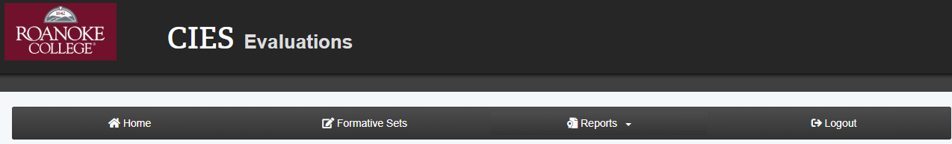

**Top line of screen**

**Home** – Clicking this link returns you to the main faculty screen.   
Use this button to exit other sections of the software

**Formative Sets** – Create or edit sets of formative questions to use in evaluations

**Reports** – View your reports for all semesters from 2007FA to present

**Logout** – Exit the CIES system

**Courses Section**  - Described on the next page.

**Overview of setting up formative questions**

This text box (below) is designed as an onscreen reminder of the main steps in setting up formative questions. It is not designed as a replacement for the full instructions, which are found on pages 4 to 5 of this instruction guide. Please refer to the full instructions the first several times you set up course evaluations.

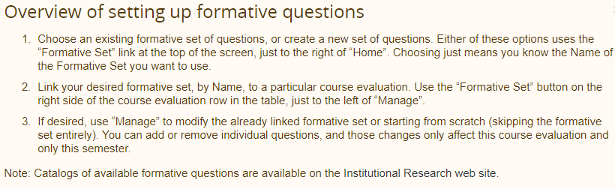

**Courses Section (will only show content during an active evaluation period, and until the next term starts)**

**Course** – Lists current active course sections in active semester  
 **Response Rate** – Shows current response rate by section for the active semester  
 **Formative Set** – Shows the name of the formative set assigned to this evaluation  
 **4th Column showing actions** – different actions are shown in different contexts, shown below.

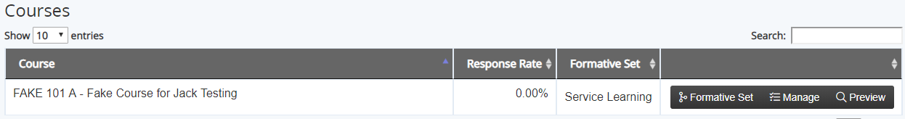  
**Before Evaluations Begin: (see image above) – Available Actions are:**

* Formative Set – Assigns a formative set to the chosen evaluation
* Manage – Manage questions for evaluation. Allows ad hoc modification of the questions for the evaluation selected, *usually for use only after a formative set has been linked to the evaluation*.
* Preview – Preview the evaluation

 **During the Student Evaluation Period, and after evaluations but Before Reports are Released: (see image above)**

* Response Rate – shows current participation rate.
* No actions in 4th column.

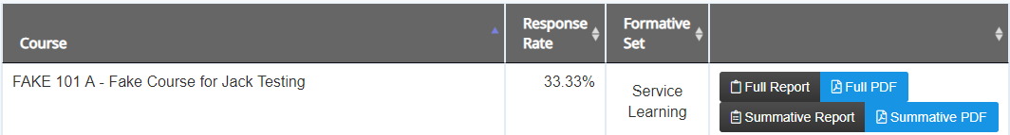

**After Evaluations End and Reports are Released: (see image above) - Available Actions are:**

* Full Report / Full PDF (in Actions list) – Get the full reports for the chosen evaluation
* Summative Report / Summative PDF (in Actions list) – Get the summative course report.

***This display is visible until the next term begins. All reports remain available via the Reports link (top of page).***

**Note: The semester summary report showing all courses is not visible on this screen. Use the Reports option at the top of the screen to see that report for the current term or any term.**

**How to add formative questions to an evaluation during the instructor setup period.**

**Overview of setting up formative questions:** (detailed instructions follow)

Step 1: Choose an existing formative set of questions, or create a new set of questions. Either of these options uses the “Formative Set” link at the top of the screen, just to the right of “Home”. **Choosing just means you know the Name of the Formative Set you want to use.**

Step 2: Link your desired formative set, by Name, to a particular course evaluation. Use the “Formative Set” button on the right side of the course evaluation row in the table, just to the left of “Manage”.

Step 3: If desired, use “Manage” to modify the already linked formative set or starting from scratch (skipping the formative set entirely). You can add or remove individual questions, and those changes only affect this course evaluation and only this semester.

Note: Catalogs of available formative questions are available on the Institutional Research web site.  
[**https://www.roanoke.edu/inside/a-z_index/institutional_research/student_evaluations**](https://www.roanoke.edu/inside/a-z_index/institutional_research/student_evaluations)

**Detailed instructions:**

1. Click on the “Formative Sets” link at the top of the screen.



1. To create a new formative set:
   1. Click the “+Create” button near the top.

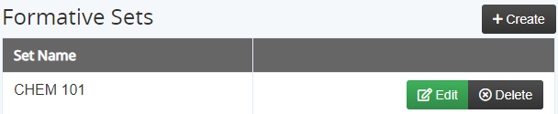

* 1. Enter a name for the question set. This name is totally arbitrary. It doesn’t need to be the name of your course. The name will **NOT** automatically link a question set to a course. The question set will now appear in your list of question sets.
  2. To add questions to your question set, click on **Edit** for that question set name.
  3. Add up to 10 questions. Choose questions from the catalogs on the Institutional Research web site, or use the Category and Sub Category listings built into the software to discover the questions you want to use. **Note: For categories with many questions, you may need to use the Next and Previous buttons to see all of the possible questions. Only 10 questions at a time are displayed.** Once you have added questions to your set, you can reorder the questions by dragging the questions.
  4. When done adding and ordering questions, just click on Home at the top of the screen. Your question set has been created!

1. To connect one of your existing formative item sets to a current term evaluation:



* 1. Click the *Formative Set* button next to the desired evaluation (*Formative Set* on the far right of the line showing your course name, next to the Manage button and the Preview button). Remember that the names of Formative Sets are totally arbitrary. Any of your Formative Sets can be used with any course evaluation.
  2. Choose which Formative Set you wish to apply from the drop down menu. **If a Formative Set had already been assigned to this evaluation, choosing a new Formative Set will overwrite the old assigned Formative Set.**
  3. Click on Home at the top of the screen to exit.

1. To modify the questions for a given evaluation (*usually used after you have linked a formative set to this course*):



* 1. Click the *Manage* button next to the desired evaluation.
  2. Use this option to add a question to this evaluation, perhaps adding to questions in a Formative Set that you selected. You can also delete a question from a Formative Set, if you wish to ask only a portion of the questions loaded from an existing Formative Set.
  3. Add / Remove questions as you would for a formative set. Your new set of questions will be used for the selected course in the current term. It does not create a new saved Formative Set.
  4. If desired, you can add questions to your evaluation by using this option alone (skipping the formative set entirely), but those questions will be used only for this evaluation in the current term.
  5. Click on Home at the top of the screen.

5. To preview the evaluation:



1. Click the *Preview* button next to the desired evaluation.
2. Note that the course name, your name, your photo, and the course meeting time are shown in the upper left at all times. This display was designed to help students remember which course they are evaluating. A countdown timer also appears in the upper right, telling students how long they have to complete this evaluation before it “times out”.
3. To walk through the different questions, click the Next button under the expanded question, or click on the text of any desired question you want to see.
4. When you finish previewing the evaluation, use the floating “up arrow” in the bottom right corner of your screen to return to the top of the page (or use the scroll bar on the right side of your screen to go to the top of the page).



1. Click on Home at the top of the screen.

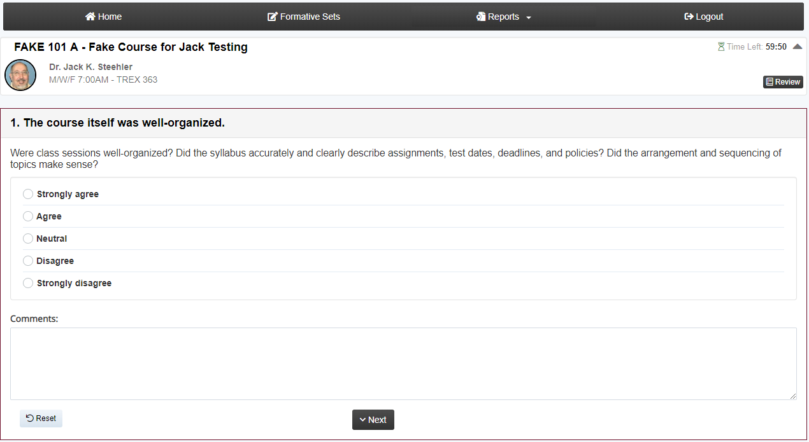

**Reports**

**All reports from all terms are accessed via the Reports item in the top line of the initial instructor view.**

**Reports are available for all terms back to 2007FA.**

**When you click on Reports, you see two or three options:**

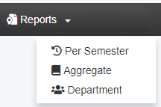

**Per Semester: Will allow you to see reports for a selected term  
 Aggregate: Will allow you to see reports for multiple terms in the same report.  
 Department: If you are a department chair, you can select a term and see departmental reports.**

**Per Semester Reports:**

1. **First, you select the desired term. All terms for which you have data are shown on the drop down menu.**
2. **Semester display:**

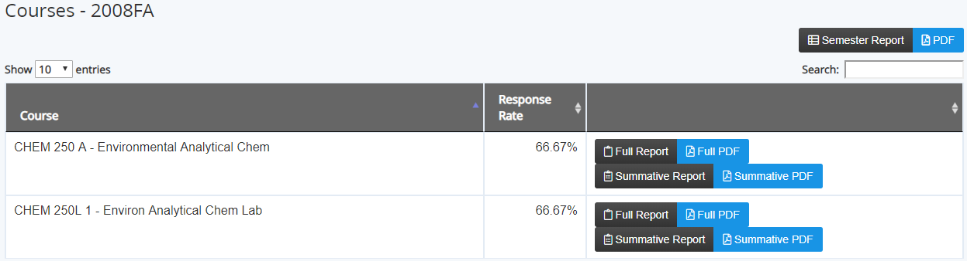

* 1. **The semester summary reports are above and to the right of the main table of courses. Both a web report and a PDF report form are available. When you click the PDF option, the report is generated and delivered to you via your browser. Different browsers handle file delivery differently. Chrome shows the file in a box at the bottom left of your screen. Firefox offers the user the chance to open the file directly. In prior versions of the CIES software, PDF files were delivered by e-mail, but the current software delivers the file to you directly in the web browser.**
  2. **Course reports are shown in a table showing all of your courses for the selected term**
     1. **Course – lists the section and course title**
     2. **Response Rate – shows the overall response rate for that section**
     3. **The unlabeled report column shows all available reports for that section**
        1. **Full report (web report included all questions and all comments).**
        2. **Full PDF (PDF report of all questions and all comments). This PDF was not available in the previous version of the software.**
        3. **Summative report (web report of the 9 summative questions)**
        4. **Summative PDF (PDF report of the 9 summative questions)**
     4. **The column titles have small arrows that allow you to re-sort the list of course sections if desired.**

**Aggregate Reports:**

1. **This report option allows you to see a report containing data from multiple terms. The first step is selecting the terms you want in the report.**

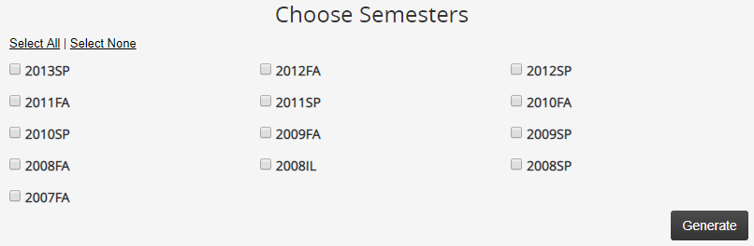

1. **The report is generated as a PDF report, which is delivered to your web browser. As noted above, some web browsers will open the file and display it, while other browsers will show it at the bottom of the screen.**
2. **The report displays each term on its own page, in reverse chronological order (most recent first). Within each term, the report displays course sections in alphabetic order.**
3. **View, print, and/or save the PDF file as desired.**

**Department Reports (Department Chair only):**

1. **First, you select the desired term. All terms for which you have data are shown on the drop down menu.**
2. **Available reports include the Full Report and the Missing Report, in both web and PDF versions.**

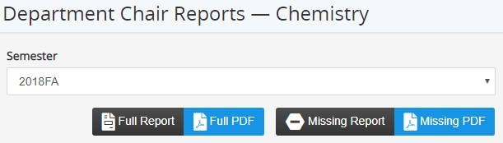

Managing Your Evaluation  
Opt Out Questions

Starting with the 2022FA term, a new set of optional questions has been provided by default on all evaluations. These questions are qualitative – students are presented with a free-response text area to write their comments. If you wish to remove these questions from your evaluations, you will need to follow the following steps **for each evaluation.**

You are also allowed to add Formative questions to your evaluation, without needing to create a formative set on this same screen.

1. Select Manage on the course you want to manage the optional questions for:

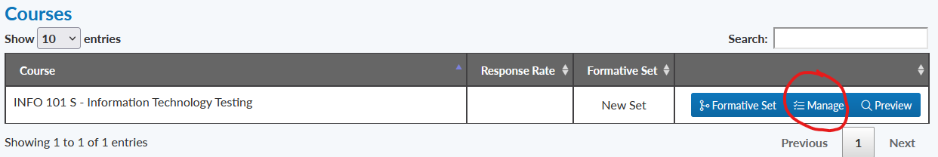

1. Questions in the Opt Out Section can be removed on a per-course basis. Press the *x* on the line next to the questions you would like to omit:

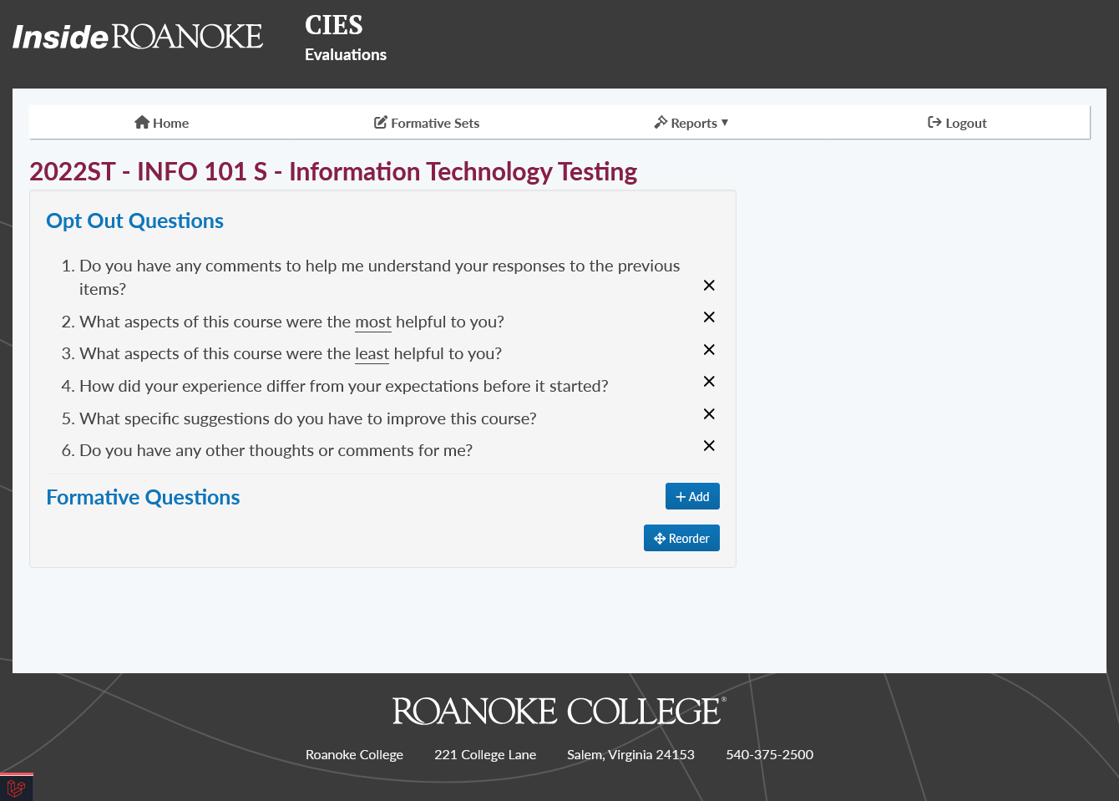

1. If you make a mistake, or just wish to restore an opted-out question, press the checkmark next to the question you would like to add back:

