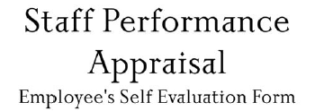

Employee Name: | Click or tap here to enter text. | Title: Click or tap here to enter text.

Instructions:
Supervisor should provide employee access to this self evaluation form so that it can be completed and returned to the supervisor prior to their performance appraisal meeting

Employee should respond to the following questions and return their completed self evaluation to their supervisor prior to their performance appraisal meeting

- What area of your work or accomplishment are you proudest of during the past year?

Click or tap here to enter text.

- What part of your work is most rewarding?

Click or tap here to enter text.

- What part of your work is most frustrating and least rewarding

Click or tap here to enter text.

- What can your supervisor do to support you better?

Click or tap here to enter text.

- Identify circumstances that may have prevented you from doing your best or areas of your work that you would do differently if you had it to do over.

Click or tap here to enter text.

- What training or professional development opportunities were you able to participate in this past year?

Click or tap here to enter text.

- In what training or professional development opportunities would you like to participate in the future?

Click or tap here to enter text.

Employee Signature | Click or tap here to enter text. | Date | Click or tap here to enter text.
Supervisor’s Signature | Click or tap here to enter text. | Date | Click or tap here to enter text.

