Guidelines for Student Researchers
Dr. Angela Allen, Subject Pool Coordinator

This document covers procedures for running studies, specifics about setting up your lab study or your online study, specifics about awarding credit to subjects, and for lab studies, a list of room availability and a template for recording subject participation.

We use an on-line system (SONA) to manage experiments. You’ll need a researcher SONA account in order to set up your studies and collect data. All students in labs or Research Seminar should have been given researcher accounts by the first week of the semester. If you don’t have one, email or visit Dr. Allen to make this happen.

The deadline for running studies, either online or lab studies, in Spring 2023 is April 10.

ONLINE STUDIES

Setting up your study in SONA

Once you’ve prepared your study in Qualtrics or a similar program, you will need to set it up in SONA so that your participants can access it.

- Go to Add New Study; if you’re editing a study that has already been created, just click on the study name. You have two options for administering it:

  - You can use the internal SONA survey feature (Online Internal Survey Study), which will automatically credit your participants. However, it’s a pretty simple survey system: no branching, for instance, and you need to be sure to save the data as it disappears after a period.

  - If you’ve set it up in Qualtrics, then link to the Qualtrics survey platform by choosing Online External Study. Follow the instructions in this video https://www.sona-systems.com/help/qualtrics/ to have credits automatically awarded.

- Your study needs information:
A name (a fun name if possible, “Do You Have A Sexy Personality?” was a very successful one a few years back).
A brief abstract is some study info that will show up in the listing with the name. That’s not a good name for it as It’s not really an abstract. But asking people “Which celebrities do you think are hot?” will get attention.
A description with a sentence or two of detail that includes the things the subjects need to do to complete the study (i.e., “subjects will complete a questionnaire about political attitudes”).
Eligibility requirements: if you only want people over 21, or women, or other limits on participating subjects, you can put that information here AND on the brief abstract. i.e. “Your Brain On Music (women only)”. It’s fine to leave it blank.
The IRB number, If the study required IRB approval
Researchers: select all the students who will be carrying out the study (everyone in your research seminar group, say)
The PI: select the professor overseeing the study.
Duration and credit: Credit allocation is based on how long the study will take: ½ credit per 30 minutes of the subject’s time for online studies. Minimum is .5 credit. You want to do some piloting to see how long the survey takes.
Preparation: If you want subjects to meet some requirement, (“subjects should not have eaten for the last hour”, say) put that here. Prepare for it to be roundly ignored. It’s fine to leave this blank.
“Active Study?”: Choose yes
Advanced settings: Most of the “advanced settings” won’t be relevant. Add your study URL as instructed in the video. I encourage you to choose the shortest sign-up and cancellation deadline that you can manage. “24 hours” is the default but it’s rarely necessary.

When you are finished, click “Add This Study”. Then, the next screen will show you this option. 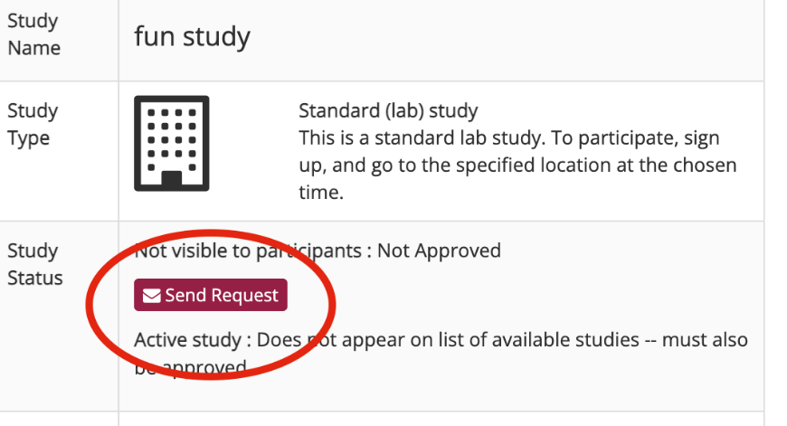
Click on Send Request if you are ready for approval. Otherwise, just navigate away from the study. You can select the study from “my studies” when you log on,and click “change study information” to modify it. Anyone listed as a researcher or PI can modify it, not just the person who set it up.

Adding timeslots: You will need to add a timeslot, so your subjects can sign up. From the study menu, choose View/Administer timeslots and click “Add Timeslot” at the top. For online studies, the timeslot is just the last date in the semester for collecting data, which can be as late as April 10 for Spring 2023. The timeslot can be changed if need be. You will need to specify a cap, which is the maximum number of subjects you hope to get. Your cap can be as high as 300.
Click “Add This Timeslot” and you’re in business! You can add timeslots before the study is approved, in which case subjects can sign up for it as soon as the study is approved. Otherwise, subjects won’t see the study until the timeslot has been added.
Granting credit: If you follow the steps in the video, credit is automatically assigned. You may want to check with your professor as to whether he or she would prefer a different way of collecting names for assigning credit.

LAB STUDIES
Setting up a study in SONA
Please see the handout with the list of available rooms before scheduling your sessions (attached).
- Go to Add New Study; if you’re editing a study that has already been created, just click on the study name. Choose Standard Study (check with your professor if you want to consider the multi-part option).
- Your study needs information:
A name (a fun name if possible, “Do You Have A Sexy Personality?” was a very successful one a few years back).
A brief abstract is some study info that will show up in the listing with the name. That’s not a good name for it as It’s not really an abstract. But asking people “Which celebrities do you think are hot? will get attention.
A description with a sentence or two of detail that includes the things the subjects need to do to complete the study (i.e., “subjects will complete a questionnaire about political attitudes”).
Eligibility requirements: if you only want people over 21, or women, or other limits on participating subjects, you can put that information here AND on the brief abstract. i.e. “Your Brain On Music (women only)”. It’s fine to leave it blank.
The IRB number, If the study required IRB approval
Researchers: choose all of the students who will be carrying out the study (everyone in your research seminar group, say)
The PI: this is the professor overseeing the study.
Duration and credit: Credit allocation is based on how long the study will take: 1 credit per 30 minutes of the subject’s time for lab studies, minimum 1 credit.
Preparation: If you want subjects to meet some requirement, (“subjects should not have eaten for the last hour”, say) put that here. Prepare for it to be roundly ignored. It’s fine to leave this blank.
“Active Study?”: Choose yes
Most of the “advanced settings” won’t be relevant, but I encourage you to choose the shortest sign-up and cancellation deadline that you can manage. “24 hours” is the default but it’s rarely necessary.

- When you are finished, click “Add This Study”. The next screen will show you this option. 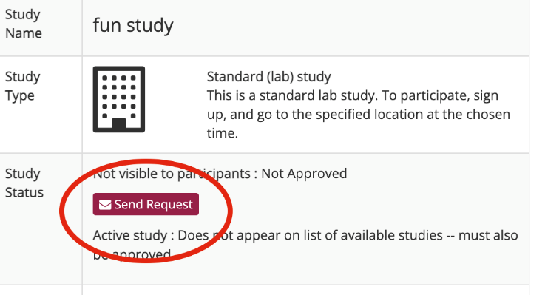
Click on Send Request if you are ready for approval. Otherwise, you can return to the study and click “change study information” to modify it. This allows you to tweak it and consult your researcher group on it before launch. Anyone listed as a researcher or PI can modify it, not just the person who set it up.

- Adding timeslots: You will need to add a timeslot, so your subjects can sign up. From the study menu, choose View/Administer timeslots and click “Add Timeslot” at the top.
For lab studies, choose the time, date and place, using the handout with available rooms and times. The system will not automatically block out times in which a class is being held so use the handout to choose your times. The latest date is April 10 for Spring 2023. You will need to specify a cap, which is the maximum number of subjects you hope to get. Your cap should be no greater than the room capacity.
Click “Add This Timeslot” and you’re in business! You can add timeslots before the study is approved, in which case subjects can sign up for it as soon as the study is approved. Otherwise, subjects will only see study once you’ve added the timeslots.
Remember, subjects will only see studies that have available timeslots. If the timeslot is full, or if the deadline for signup has passed, the timeslot will not be visible to them.

Preparing to run your study

Prepare for each session by assembling a sufficient number of:
a) Informed Consent forms
b) Debriefing forms (unless oral debriefing)
c) Any written materials you may be using for the study (scantrons, instructions, etc)

You can keep your materials (questionnaires etc) in the locker in the Student Lounge. The lock’s combination is: _MAP7__. The cabinet also contains signs (see below). In addition, make sure that all group members have copies of materials stored on their Z drives, jump drives, Google docs or whatever.

Before each session, put a sign outside the door of the room where you are holding your study. (For example, “Welcome to the Surfer Study”). Put a second sign saying “Experiment in Progress” on the door after the session starts.

If you are starting your study after 4 p.m., make sure the door is left unlocked by posting a “do not lock” sign earlier in the day.

Please remove all signs once you’re finished with the study.

For All Studies

Communication with Participants through SONA

To view the list of participants who have signed up for your study, first select the study and timeslot you wish to see. Then click the Modify button. The list of participants, along with their email addresses, will be listed. There is also a link to a printer-friendly list of participants.

If you wish to contact a particular participant, open the timeslot and click on the Contact link that will appear next to each participant’s name. l. If you want to contact all participants, you can click the Contact All Participants choice at the bottom of the Modify Timeslot page. You will be taken to a page where you can fill out a message that the system will send to the selected participants. The message is auto-filled with some basic information about the study, so participants are aware of which study you are referring to. You may remove this information if desired. You may choose to receive a copy of the email that you send.

Please be professional in interactions with subjects, even the occasional whiny, clueless, defensive or belligerent ones…you’re representing the Psychology department. That includes in-person and email interactions.

Running the Study and Granting Credit
If it’s a lab study:
Be early to your session!! However, it’s a good idea to wait 5 minutes past the start time if anyone is still missing. If at all possible, schedule at least two of you for each session, in case one of you is late or sick. If the experimenter does not show up, the students who show up get full credit.

Informed consents: If a lab study, make sure you go over these with the students and tell them that IF they want to participate, they can sign. Keep these separate from the data to protect anonymity. Put them in a separate envelope marked INFORMED CONSENTS. You can turn that in to your instructor when your study is finished. Make sure the participants understand that they will receive full credit just for showing up to the study, and that signing the informed consent does not mean they have to finish the study. Their obligation is to show up and listen to a description of the study’s procedure.
Make sure that you are consistent in your behavior and presentation from subject to subject. Write out a script that all group members will follow. Be kind and thank the students for their participation. Be professional—don’t eat or chat or fiddle with your phone during the study. Remember the debriefing!
If participants do more than one task, make sure that you keep their results together. Make sure that you organize your data so that you know what conditions people were in. (You can mark codes on things, like Subject 1, etc.).

Granting Credit in SONA

If you’re using the automatic crediting option for online studies, you won’t need to assign credit but at the end of the study, you’ll need to take care of uncredited timeslots (people who signed up for the study but didn’t actually do it). Otherwise, you’ll want to manually credit (or not) participants.

You should grant credit within 24 hours for subjects who have participated. Subjects get anxious if their credits aren’t awarded quickly; don’t wait more than a couple of days or you WILL be pestered.

To grant credit or note a no-show, find the timeslot and click the Modify button. You will see a list of participants. If they’ve completed the study, give them credit. If an online study, mark anyone who signed up for the study but didn’t complete it by the date as an excused no-show. If participants didn’t show up to a lab study, assign “excused” or “unexcused” depending on whether they contacted you.

Click on the Update Sign-Ups button at the bottom of the list of sign-ups to save your changes.

Did someone show up without having signed up ahead of time? No problem! Click on “Modify” for the timeslot in question. There is a manual signup option at the bottom of the page. Sign them up retroactively and then grant the credit.

If desired, enter any comments about the session in the Comments section (generally, this is used to indicate the reason for denying credit). Participants will see anything you enter in the Comments section for their sign-up, and these comments will be included in the email sent to participants when a credit grant or revocation occurs.

Click on the Update Sign-Ups button at the bottom of the list of sign-ups to save your changes.

For lab studies, please record student participation records on a Psychology Study Record form, which should be turned in promptly to Dr. Angela Allen as a back-up to the online record. Forms are available online and in the materials cabinet. A copy is attached.

Questions? Please contact Dr. Angela Allen at allen@roanoke.edu.

Research Room Availability
Spring 2023

Room | Capacity | General Availability
301 | Up to 30 participants has a projector | M 4-7pm  T 2-6pm  TH 12-3pm
501 | Up to 10 participants  has a projector | MWF 2-7pm  TTH 2-6pm
502 | Up to 25 participants has a projector | M 4-7pm  WF 5-7pm  TTH Busy
513 (computer lab) | Up to 12 participants | M 8-2pm  WF 3-7pm  TTH 5-7pm
514 (computer lab) | Up to 12 participants | M 8-2pm  WF 3-7pm  TTH- 5-7pm
515 | Up to 25 participants has a projector | MF 4-7pm  W Busy  TTH Busy
527 | Up to 20 participants | MWF 8-1pm  TTH 10am-1pm; 5-7pm

Psychology Study Record

Study Name:_______________________________

To be turned into Dr. Allen after credit (or no-show) has been recorded online

Participant Name | *Credit | Date

* If credit is awarded, write the number of credits earned (e.g. ½ or 1). If the participant was an excused no-show, write Exc. If the person didn’t show up and was not excused, write NS.

