**Approving Student Time - Computer**

1. After logging in to Self Service, click on TIME APPROVAL. You can get to Self Service a few ways, one is through the Inside Roanoke homepage, [www.roanoke.edu/inside](http://www.roanoke.edu/inside). (Note: Your screen may look different, depending on your role.) You may also approve time through Self Service in the Ellucian Go App; that process is detailed in another document.

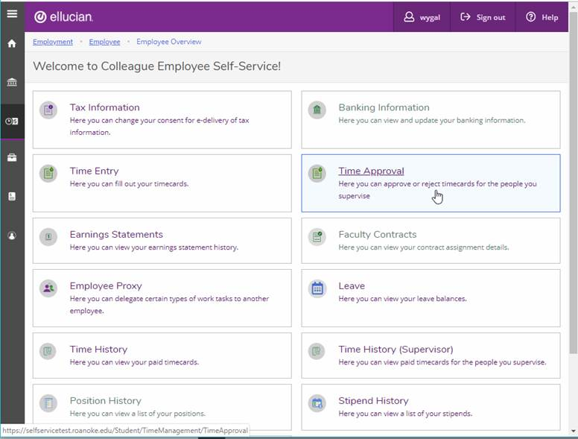

1. All of the employees that you are a time approver for will show up in a list. Notice this list has a mix of bi-weekly staff and bi-weekly student employees. The tabs differentiate student from staff payrolls.
   1. Student employees should be entering time on a daily basis and sending their timecard to you for approval weekly, following the end of the pay week.

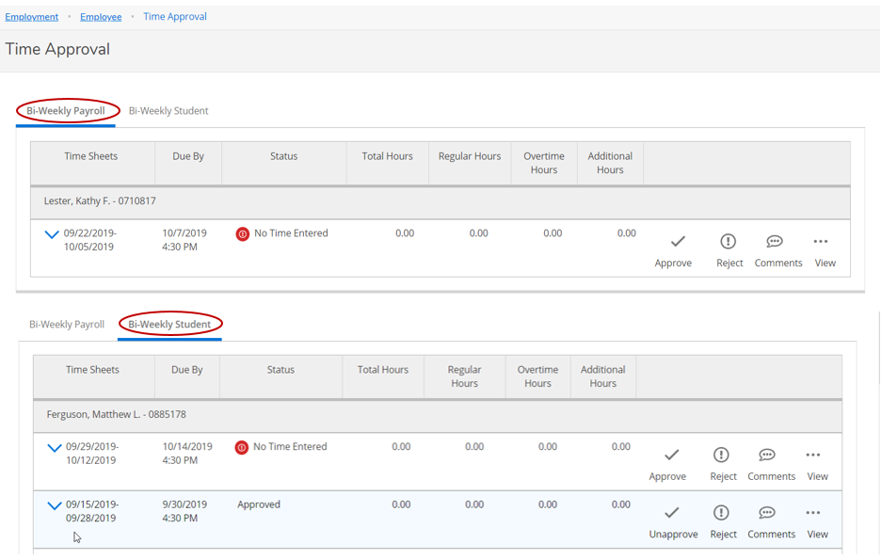

1. Select your first student to approve and view detailed timecard information by clicking on the “view” tab.

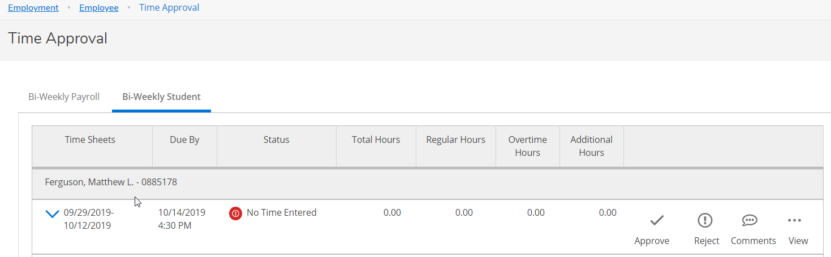

1. Review time. You can make comments by selecting COMMENTS from the OTHER ACTIONS button. If edits need to be made to the hours worked, you have two options:
   1. Edit the timecard yourself and click APPROVE
   2. Reject the time card from the OTHER ACTIONS drop down menu and send it back to the employee.

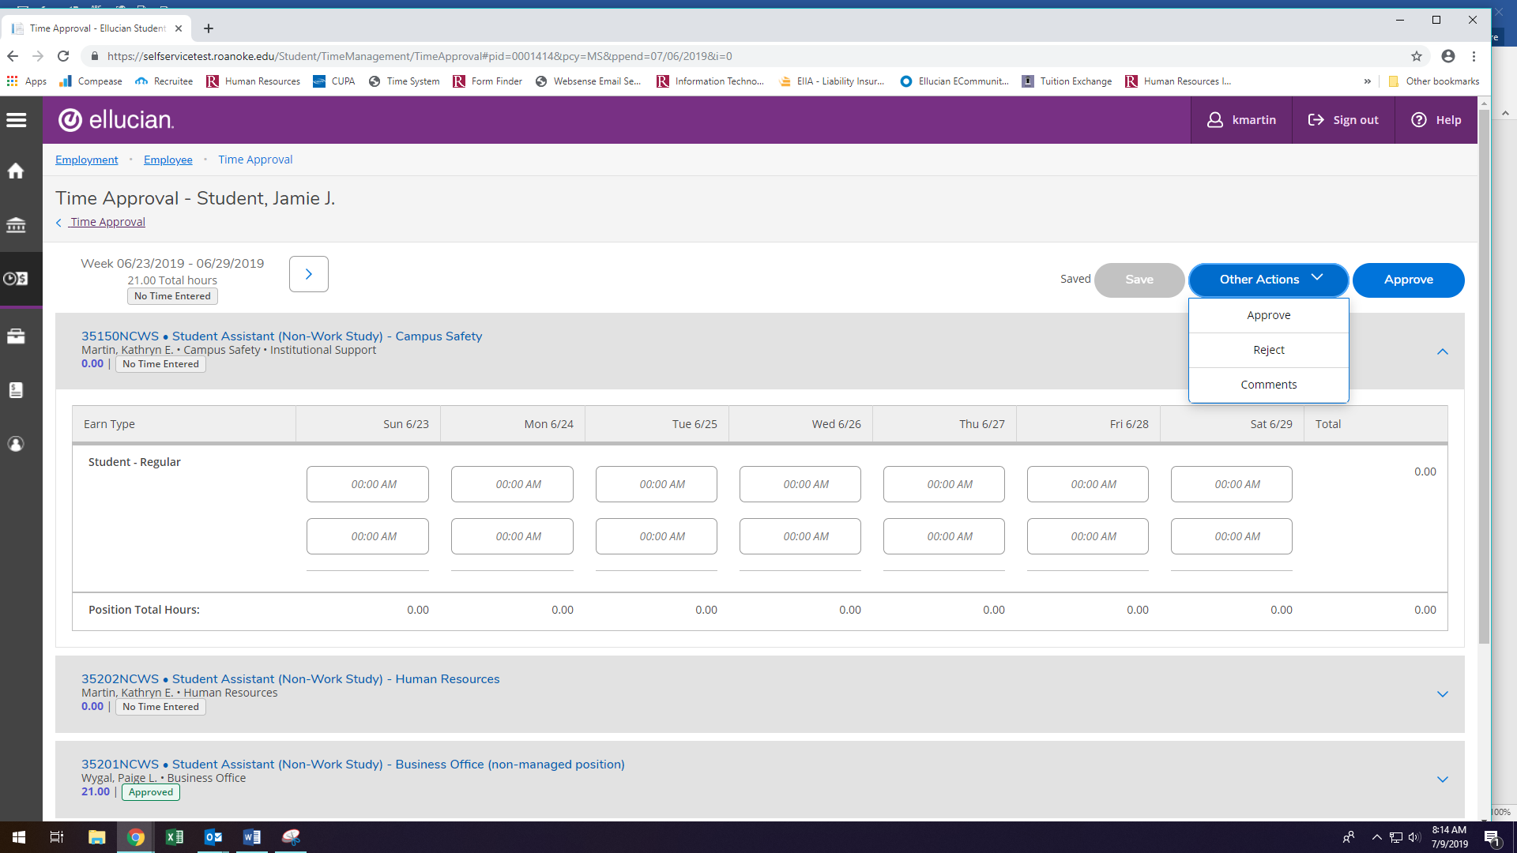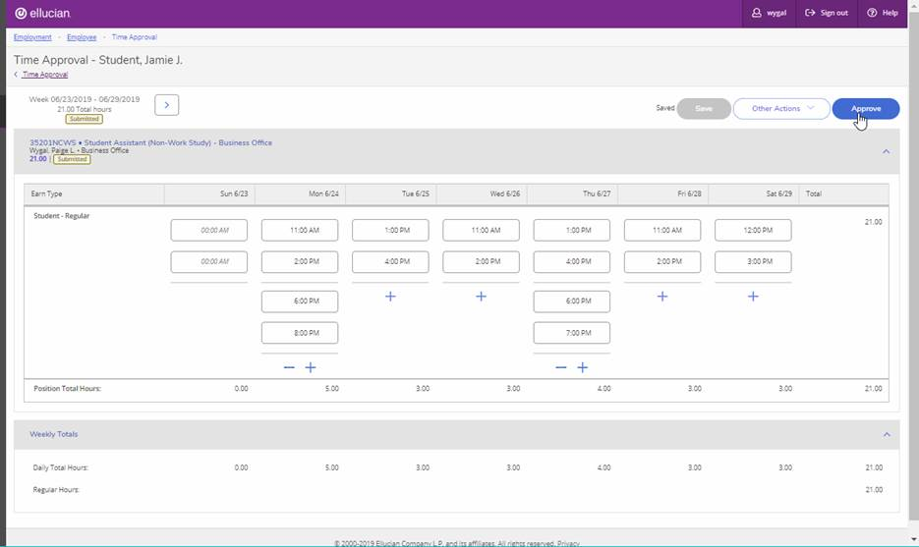

1. Click arrow button for the second week. Review time following the same process above. Once time is correct, click APPROVE.

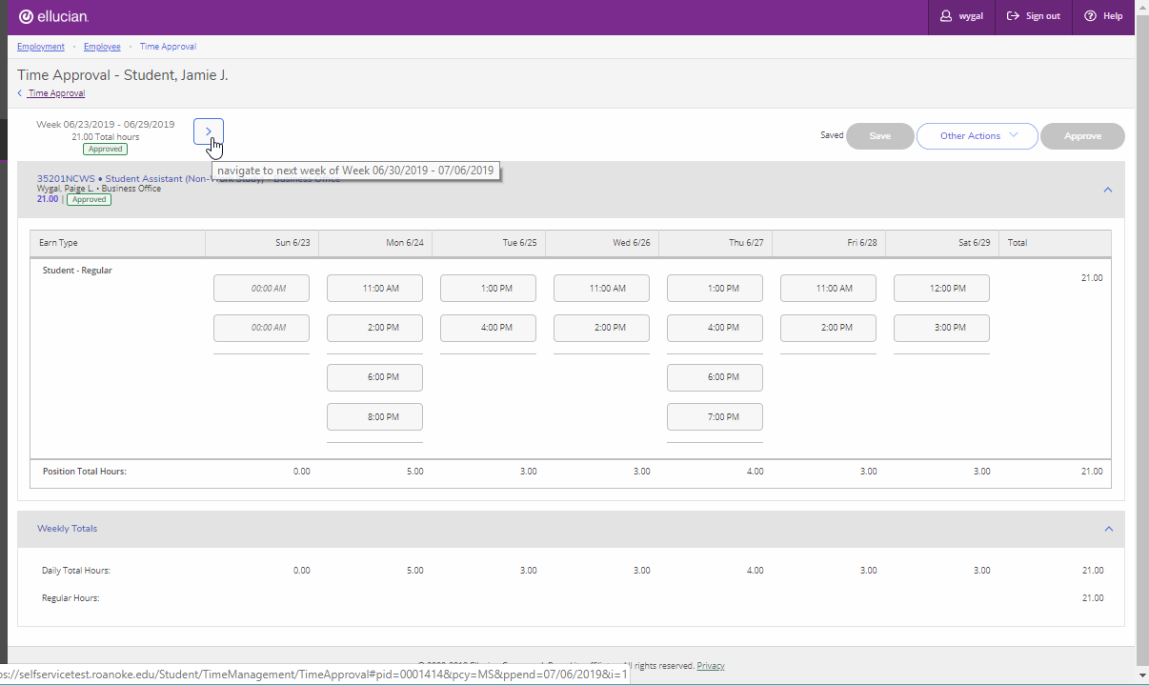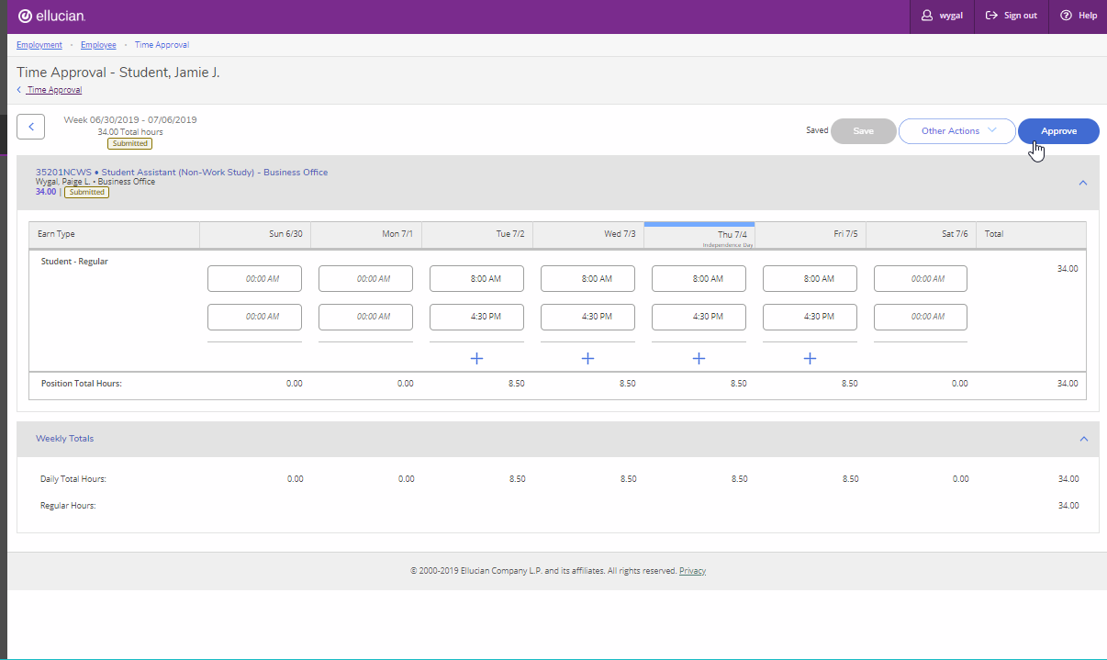

1. After clicking “Approve” button, click “<Time Approval” to bring you back to main screen.  Repeat the process for your other employees. Verify all your employees are approved by looking for the green box with the word “Approved”.

