Student Time Entry Instructions - Computer
- Once logged into Self Service you will see the screen below. You can get to Self Service a few ways, one is through the Inside Roanoke homepage, www.roanoke.edu/inside. Click on EMPLOYEE to enter your time. (You may also enter time through Self Service in the Ellucian Go App; that process is detailed in another document.)
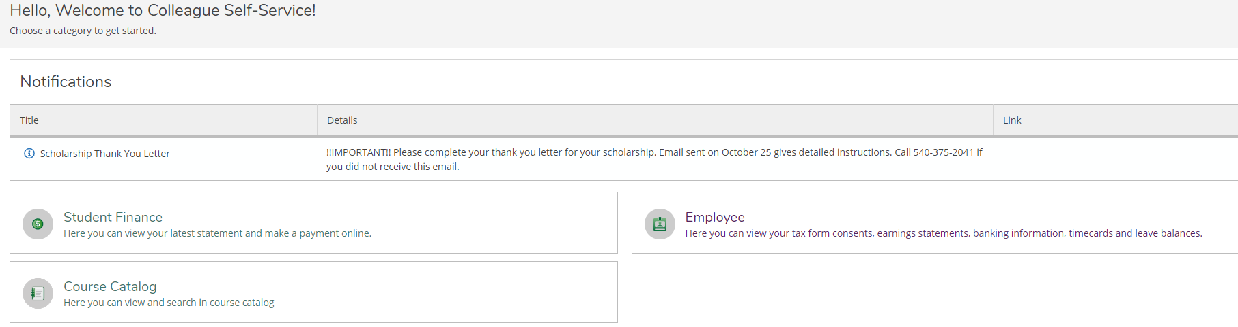
- The active pay period will display. Select the pay week you want to enter time by clicking the BLUE ARROW on the far right. Please enter your time daily and submit your entire timecard weekly.
  - In this example, this student has one job.
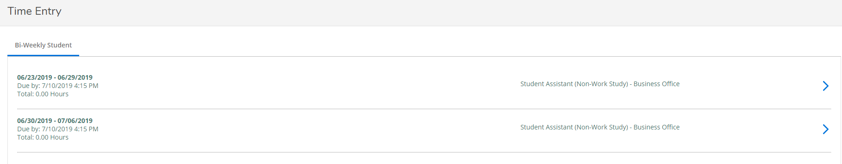

  - Multiple jobs will look like this; still click the blue arrow to expand all timesheets.
  - Select the timesheet you wish to enter hours for by clicking the blue down arrow to the right of the grey bar. In this example, the student has entered time in the first job, but not the other two.
    - If you have no hours in this pay period for a job, do not enter hours. Submit the timecard with zero hours. 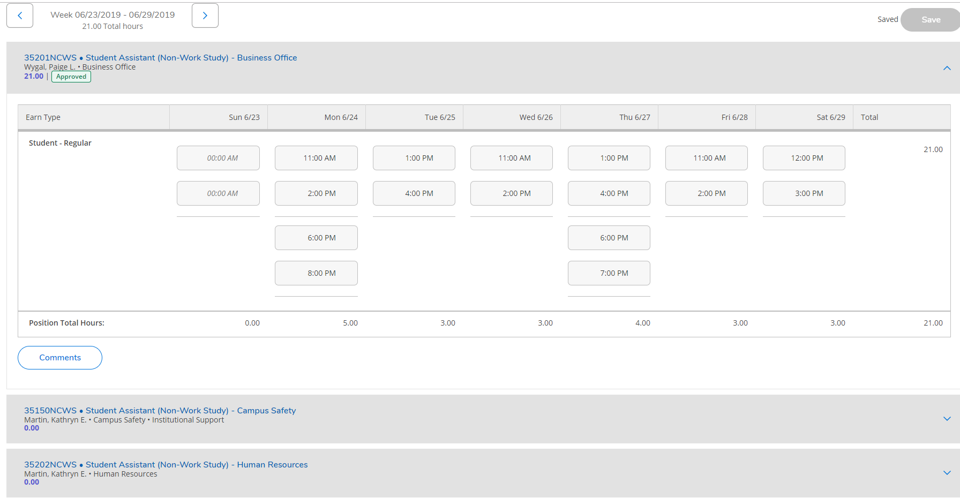

- With the correct time sheet selected, enter your in and out times.
  - You don’t have to pick from the drop down menu. If you clocked in at 11:00 a.m., you can enter “11 a” and the system will record 11:00 a.m.
  - Time will automatically save as you key it in, but you can click Save if you like.
    - Click the blue “plus sign” on a day to add in hours of a split shift for that position. (Do not enter another job’s hours using the plus sign. Those hours go on that job’s timesheet.)
  - You may enter in comments for your supervisor, by clicking the COMMENTS button. Comments are not required.
  - At the end of the pay week, click on the blue SUBMIT FOR APPROVAL. This will send your time to your supervisor for approval.
  - You can make changes to your timecard up until your supervisor approves your timecard. However, your supervisor will get an e-mail every time you edit and resubmit your timecard, so try to minimize incorrect entries.
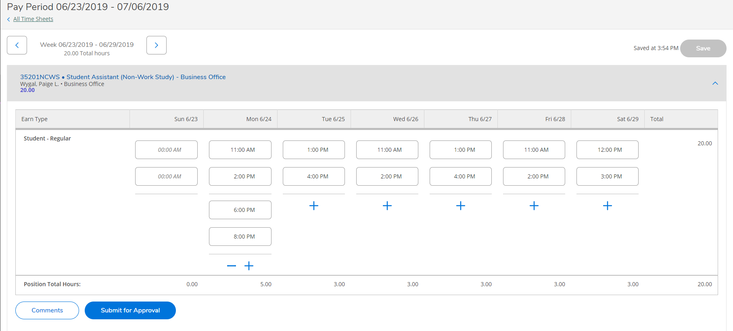
- After clicking SUBMIT FOR APPROVAL you will see this pop up in the upper right corner of your screen. Your Supervisor will get an e-mail that you have submitted your timecard.

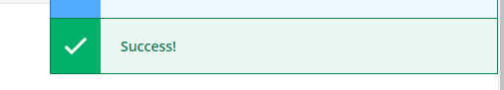

OTHER TIPS

To navigate between pay weeks, click the blue arrows on either side of the pay period text.
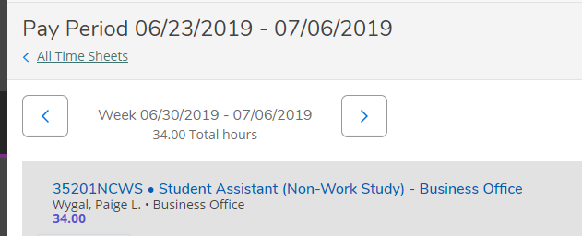

If you made a mistake on a timecard and you need to correct it, click RETURN TO TIMECARD. Once you’ve made your changes, resubmit the time. Keep in mind that your Supervisor will get an email for each action that you make to the timecard.
