ROANOKE COLLEGE( Marijuana Policy
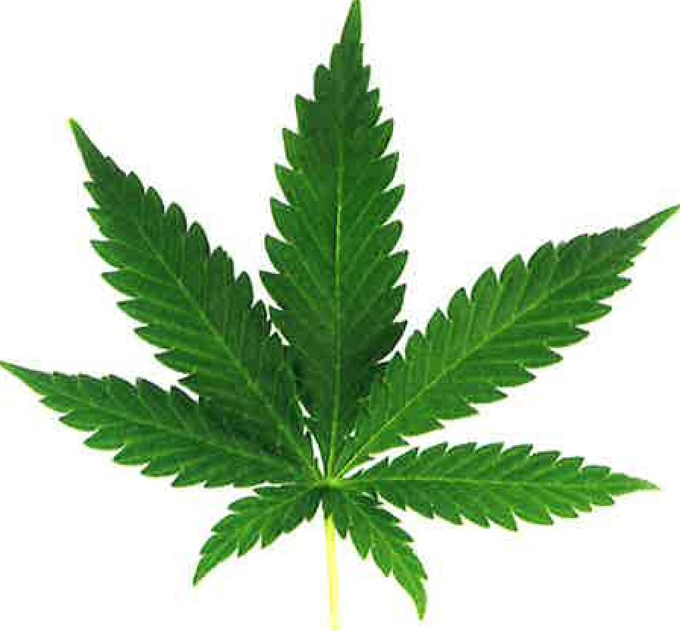
You may not use or possess marijuana or marijuana paraphernalia in any form anywhere on Roanoke College property. Policy violations will result in marijuana education, probation, or suspension in the case of egregious or multiple offenses.
Keep it off campus!
Marijuana can negatively impact
academic success and personal well-being.
Educate yourself on the effects of marijuana use: https://www.dea.gov/sites/default/ files/2020-06/Marijuana-Cannabis-2020.pdf

KNOW THE FACTS/FAQ

Q: Now that recreational marijuana is legal in Virginia, will Roanoke College change its policies prohibiting marijuana use and possession?
A: No, marijuana use and possession remain
against college policy. The federal government still considers marijuana to be an illicit drug. The college must abide by federal laws, including the Drug- Free Workplace Act and the Drug-Free Schools and Communities Act. If we fail to comply, the college
could lose its eligibility for federal funding, including student financial aid programs.

Q: What if I use marijuana off-campus or possess it at my off-campus residence?
A: The college will no longer consider the off-
campus use/possession of marijuana in compliance with Virginia law to be a violation of college policy. It is against Virginia law for those under age 21 to use or possess marijuana. The College will hold students responsible if they fail to maintain good conduct on or off-campus.
Q: Can I use medical marijuana on campus? A: No, all marijuana is prohibited from college property.

Q: Does RC's marijuana policy apply to faculty, staff, guests, and visitors?
A: Yes, Roanoke College policy also prohibits faculty, staff, guests, and visitors from using, possessing, distributing, or being under the influence of marijuana while on college property or during college activities.

Q: What happens if I violate the marijuana policy? A: Violations of marijuana policy will be referred through the student conduct system. In addition
to marijuana education, sanctions can range from probation to suspension to expulsion in the case of egregious or multiple offenses.

Q: Where can I learn more about the state law?
A: https://www.cannabis.virginia.gov/

Do you have questions or concerns about your marijuana use?
For a confidential appointment, contact
Student Health and Counseling 540-375-2286

