How to create an online assessment in Inquire

Go to your Inquire class and Turn Editing On

Add an Activity- Click on Quiz

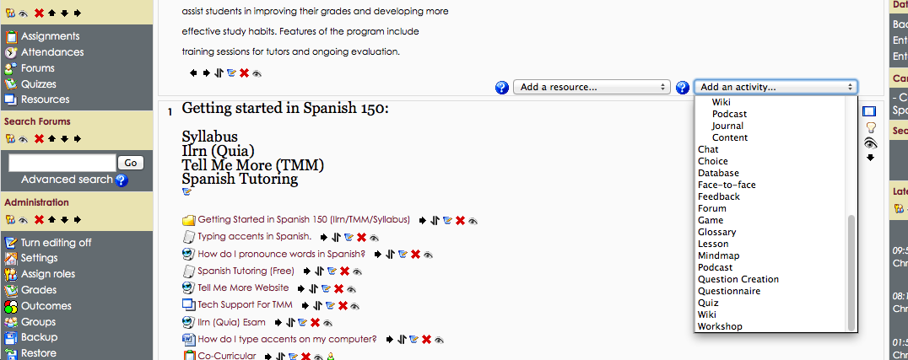

Add your new Quiz (Assessment)
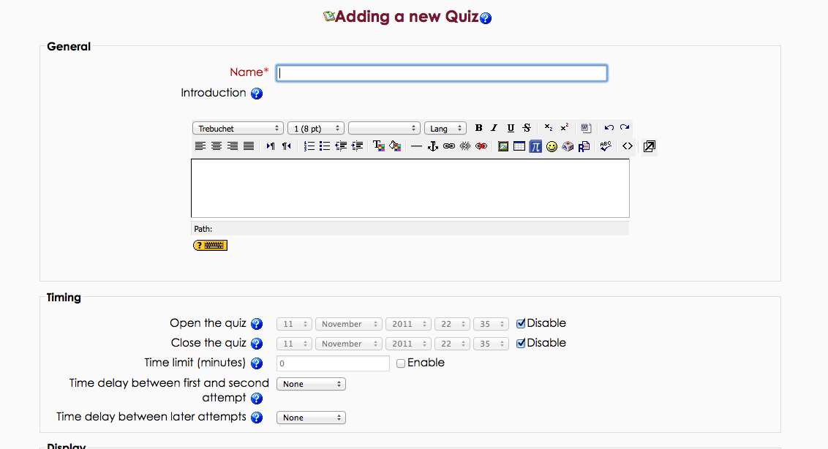

Uncheck all of the boxes (until all students have taken the assessment) and Change Grade Category to Quizzes, Tests, Etc…

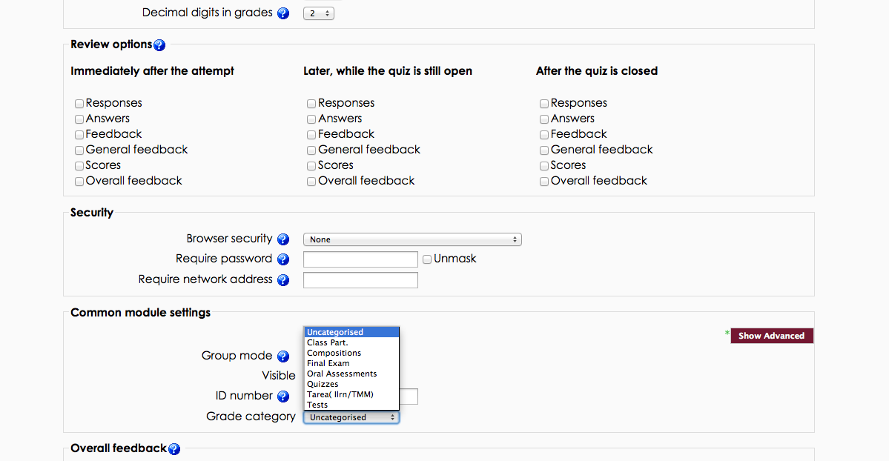

Start adding questions to the Question Bank

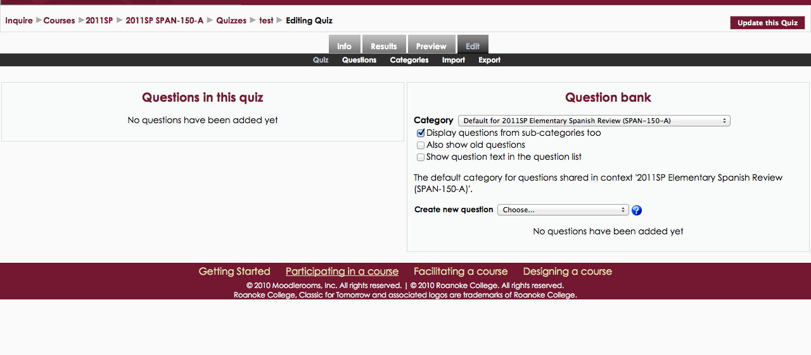

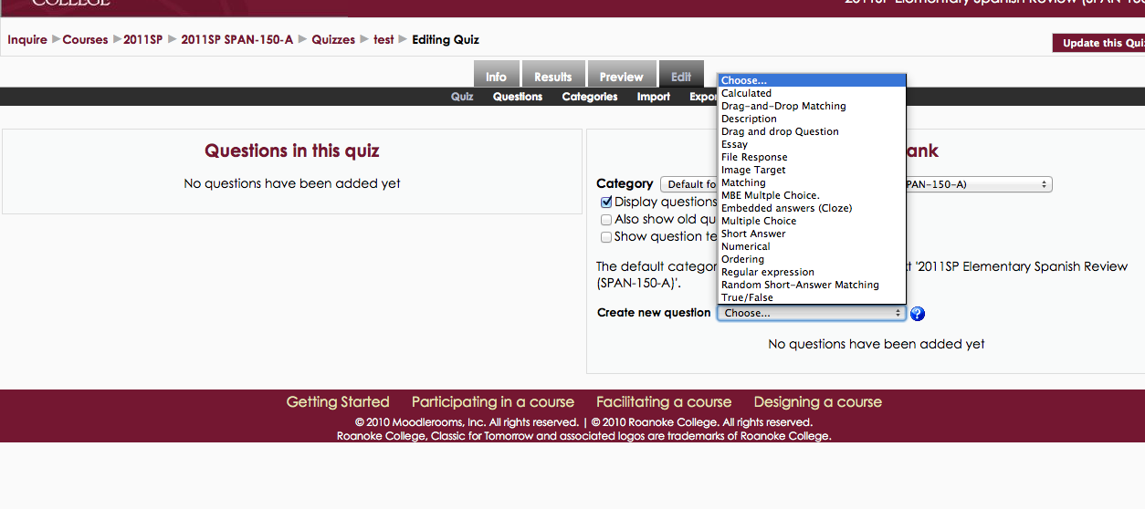

Add the correct answer and the grade of 100%
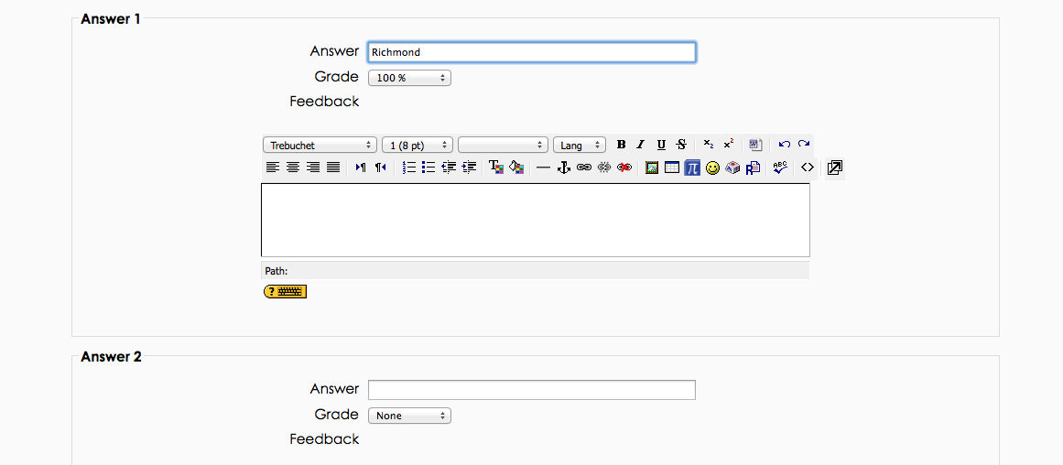

Create your next question.

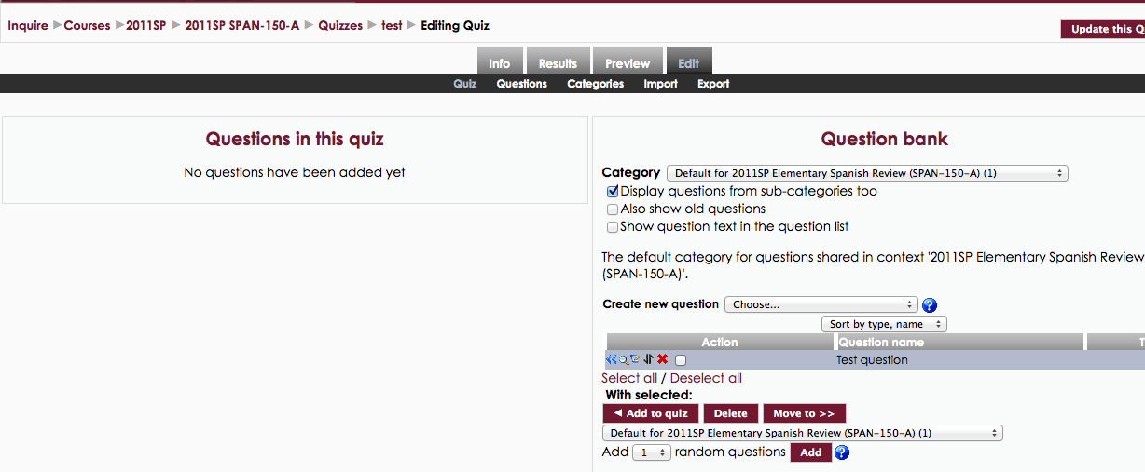

Once you finished, SELECT ALL and CLICK ON ADD TO QUIZ

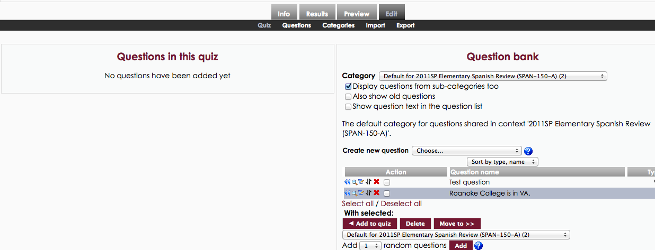

Adjust the points if needed and click on SAVE CHANGES.

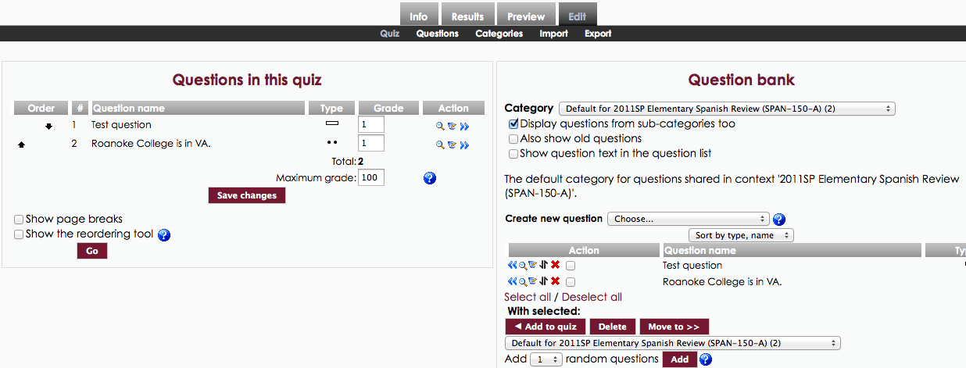

You can now PREVIEW THE ASSESSMENT

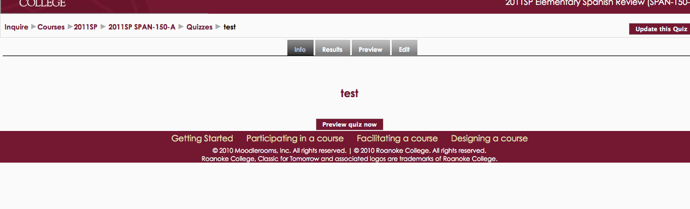

Click on the paper and pencil to edit any question.

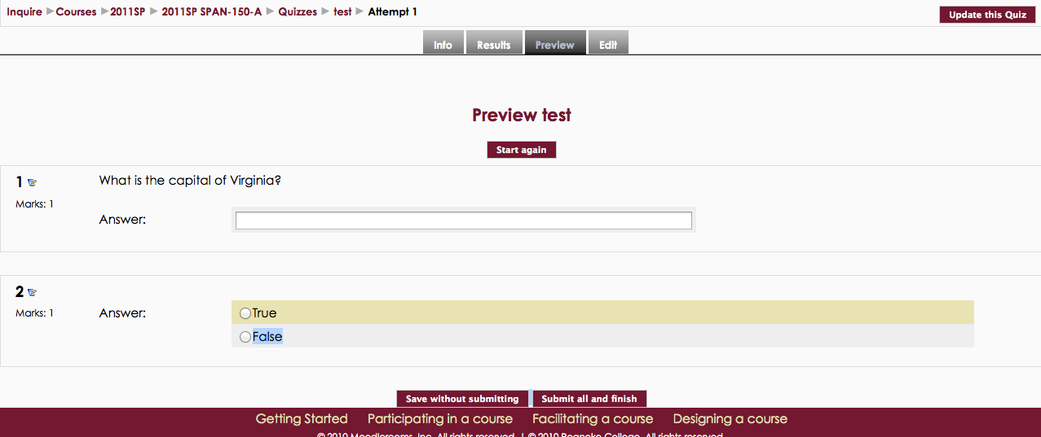

For the best results:

Use FIREFOX

Students may not open other pages or use the back page button.

Use a password

Make a couple of paper copies just in case there is a problem

Provide feedback (in settings) once you have graded all sections

Give students scrap paper

